Instruction for the Car Kit v1.0
1.Connect the computer and Anchor together using USB-TTL.

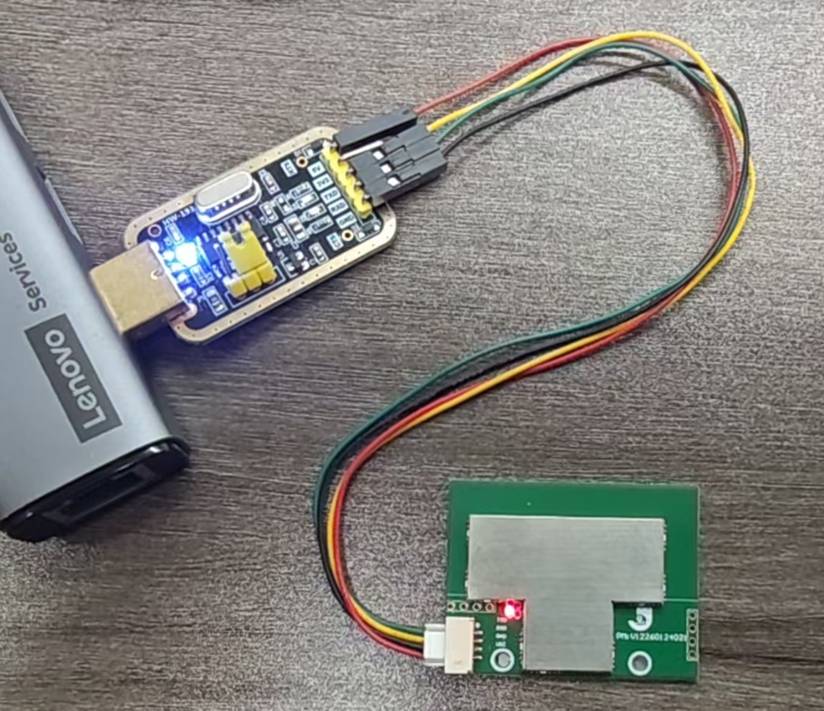

2.Supply power to the tag hardware.

3.Extract the compressed file.The link is as follows:
MaUWB_AOA-Gen2/MaUWB_AOA_Assistant.zip at main · Makerfabs/MaUWB_AOA-Gen2

4.Open & Connect MaUWB_Assistant.exe
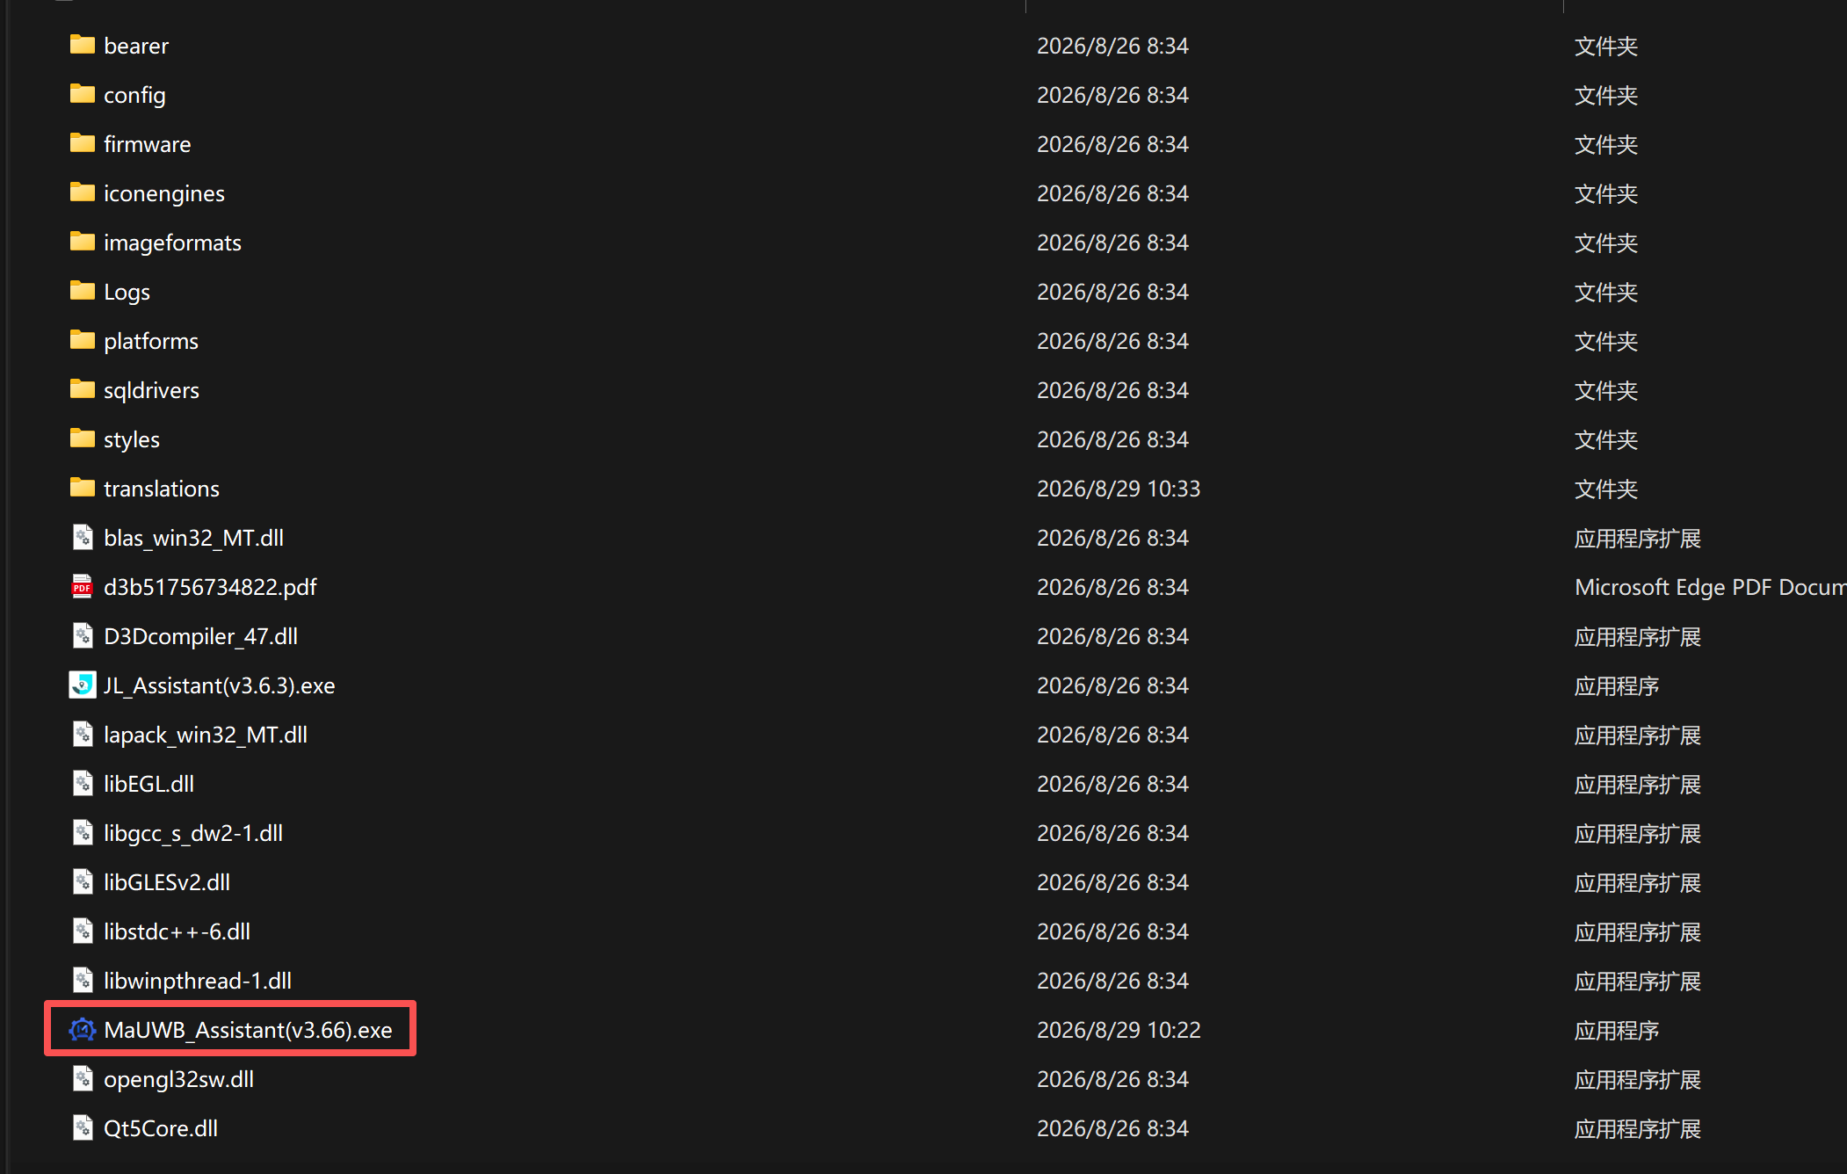
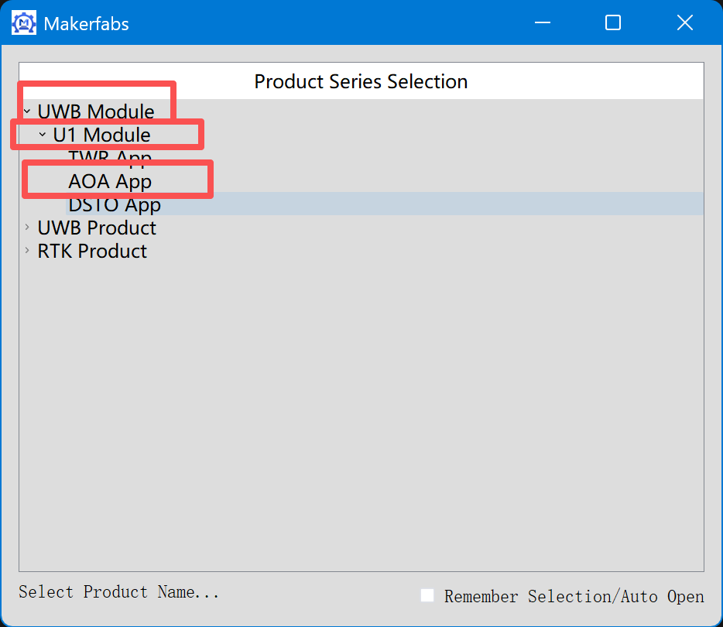

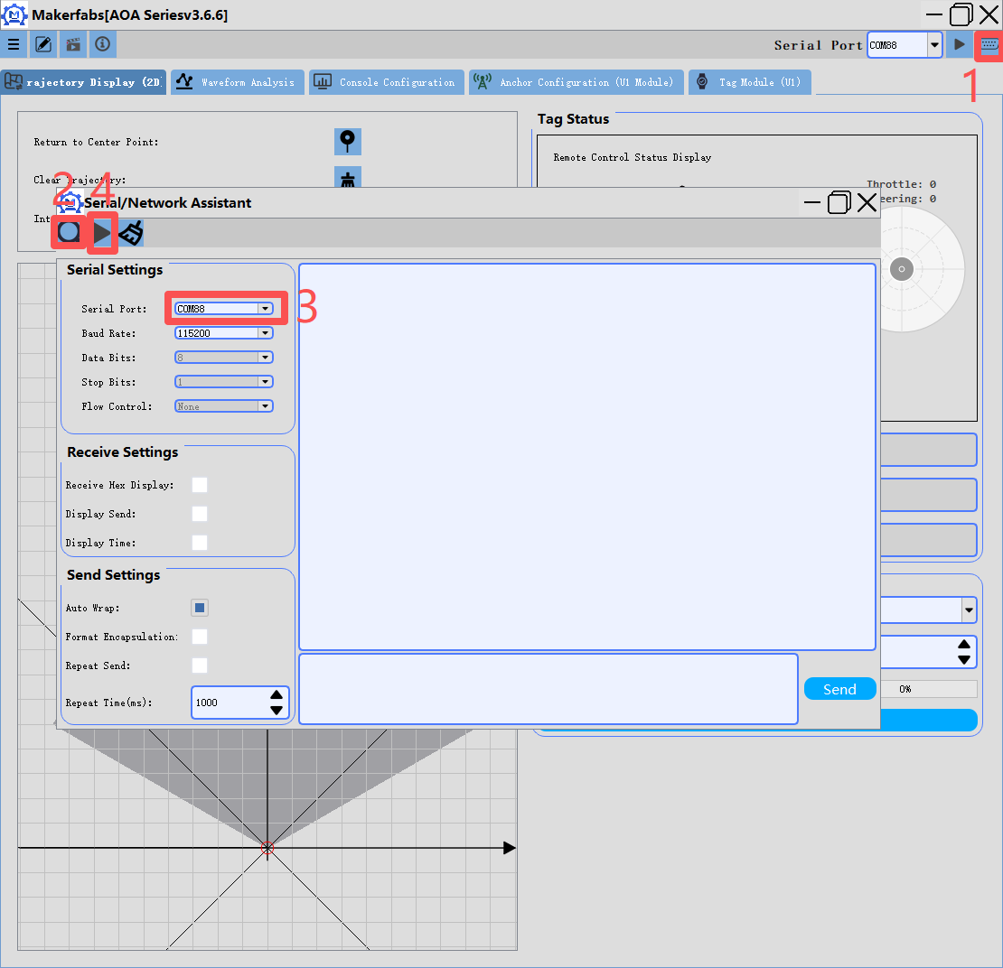
Note: When the data is reported, it will show as garbled characters in the [Serial/Network Assistant] section. This data is not garbled but rather hexadecimal data.

4.Unbind tag
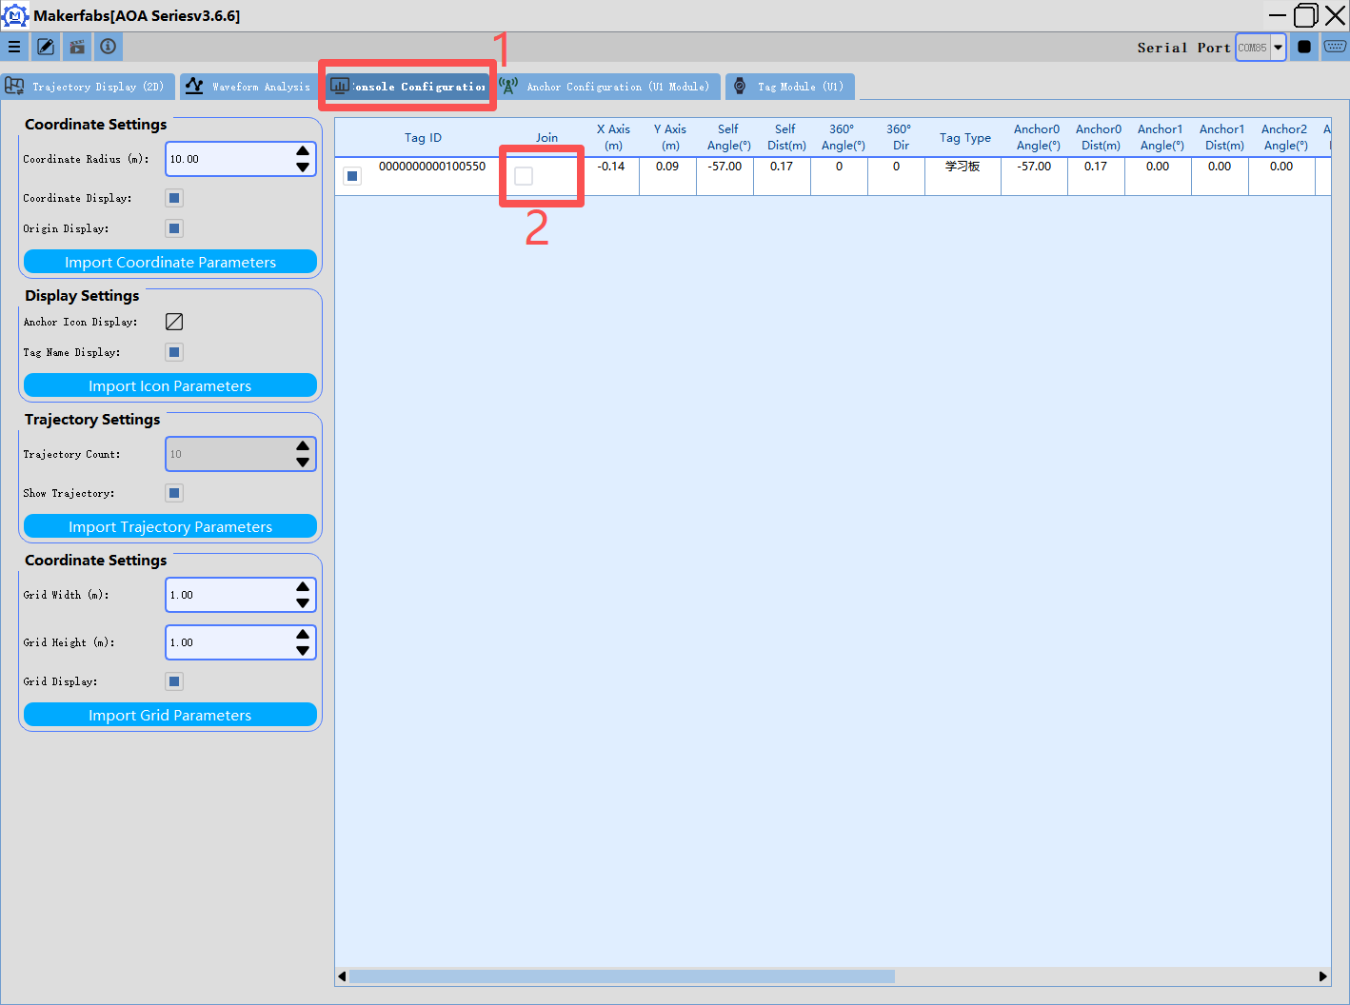
Note: If a user has multiple tags, they need to switch between tags. First, the original tags must be unbound before new tags can be bound.

5.Bind the corresponding tag.

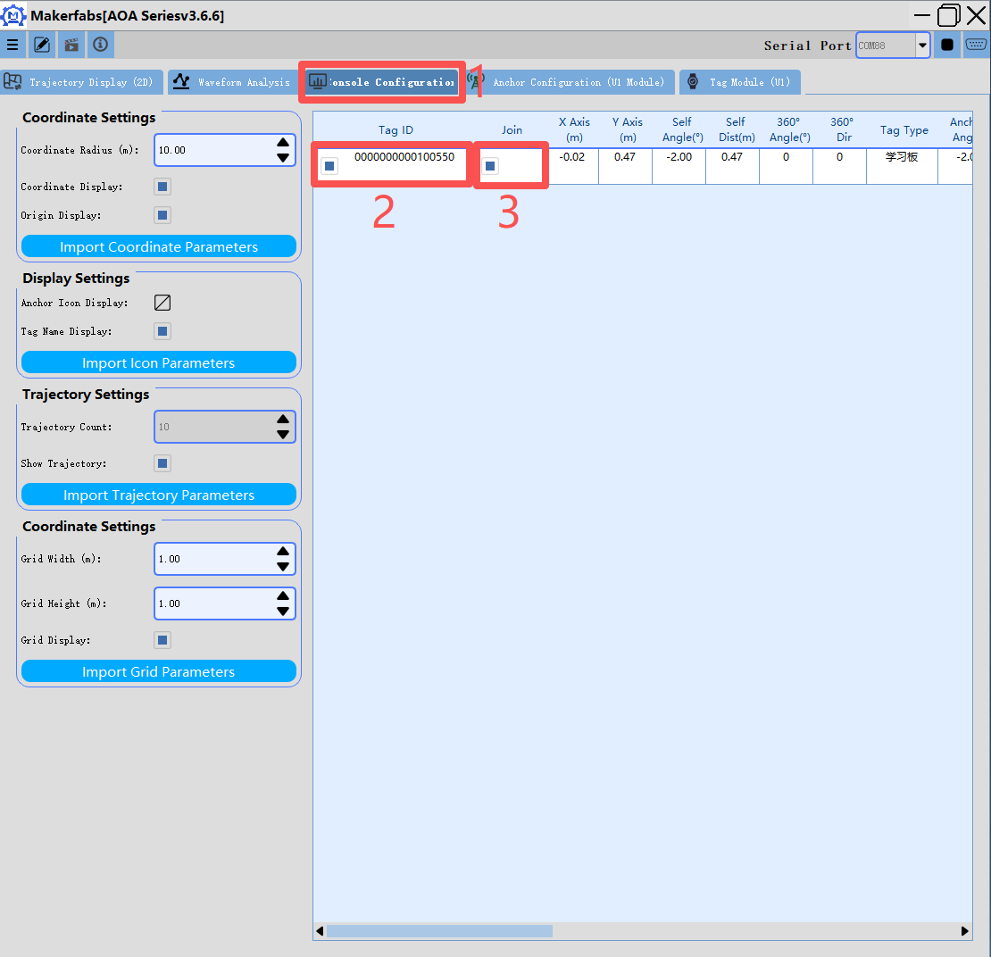
Note: If a user has multiple tags, they need to switch between tags. First, the original tags must be unbound before new tags can be bound.

6.After binding, you can check if the binding was successful. Click the remote control button to view the remote control status display.
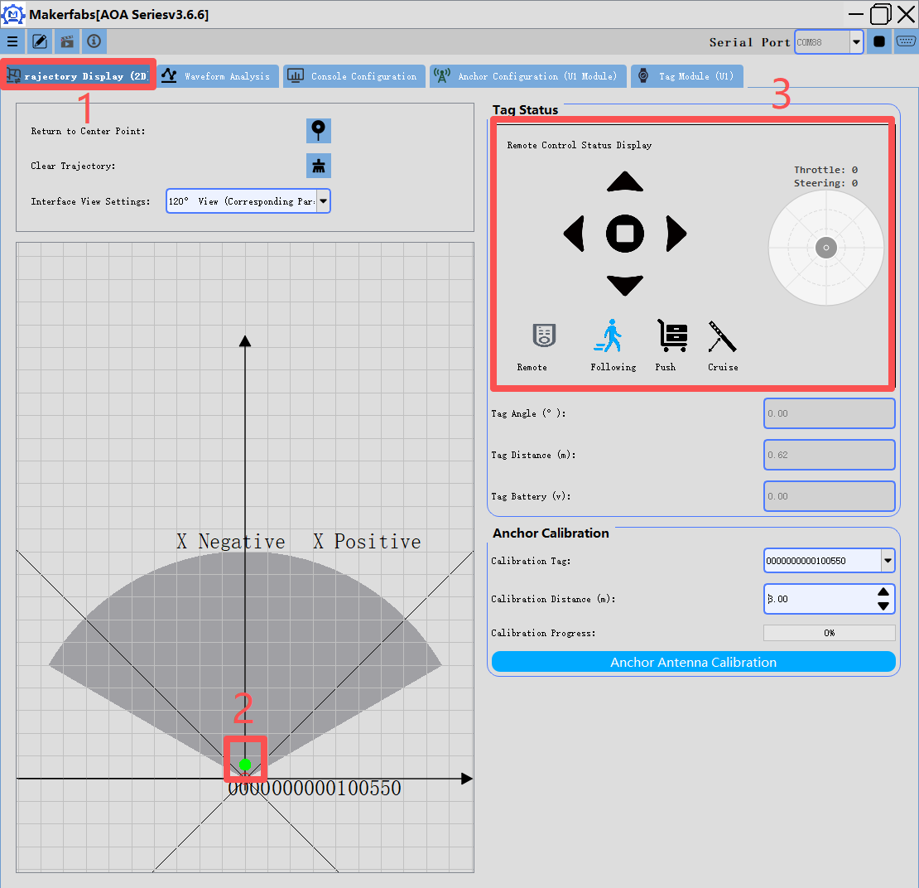

7.The angle waveform diagram shows.
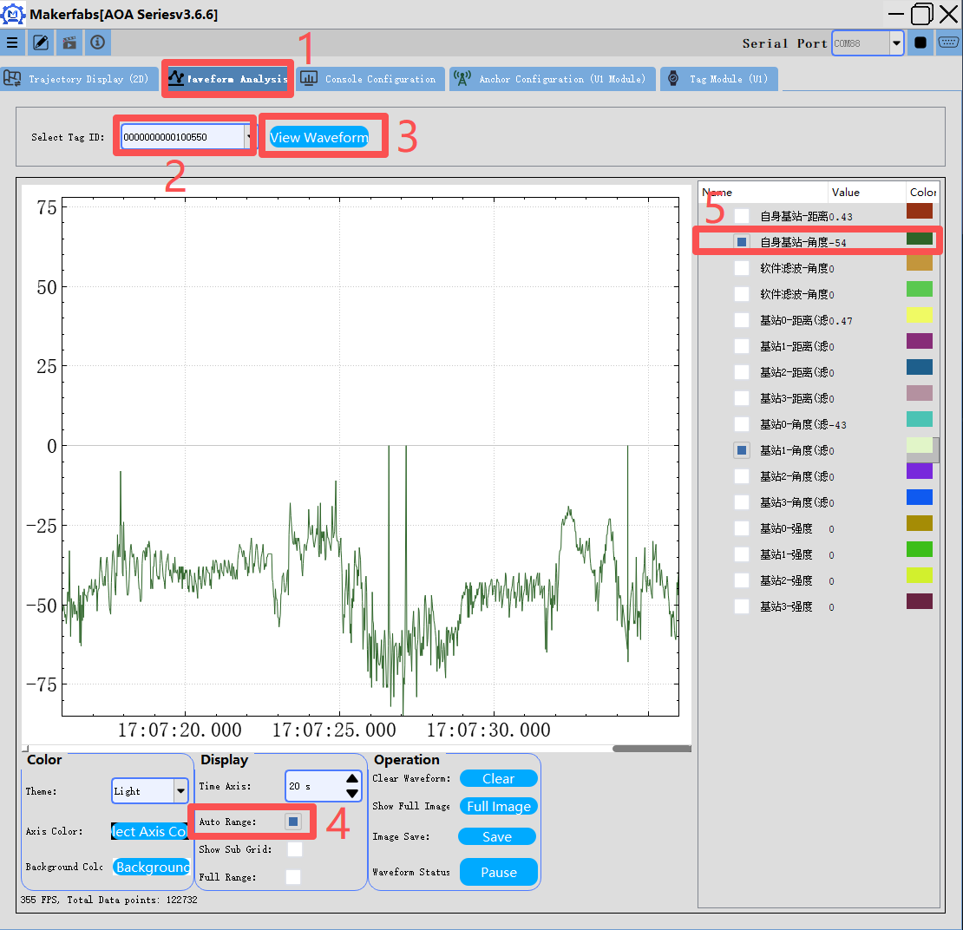

8.Base station configuration.
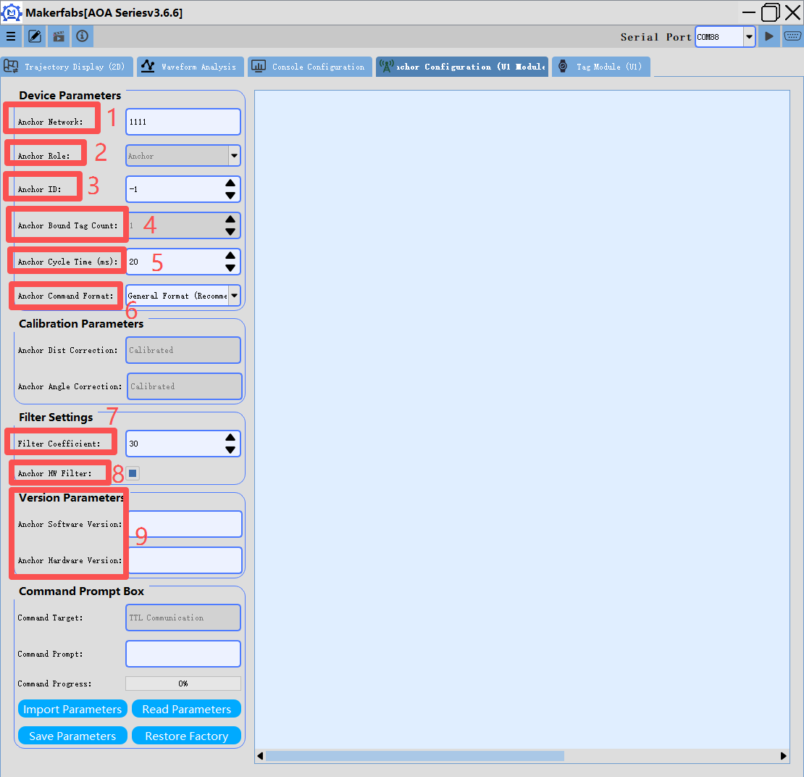
Parameter Description:
[Device Parameters]
Base Station Network(1): Network ID (This parameter can be used to set the network ID and the base station number ID to avoid interference between multiple sets)
Base Station Role(2): Default
Base Station Number ID(3): Tags within the same network ID can communicate with different base station number IDs. Each base station can obtain distance and angle
Number of Base Station Binding Tags(4): Default
Base Station Single Cycle Duration (ms)(5): The duration of communication between the tag and the base station
Base Station Command Format(6): The base station can adapt to multiple protocols. Users can choose themselves
[Filter Parameters]
Filter Coefficient(7): The larger the coefficient, the smoother the angle. Recommended value (10-20)
Base Station Enable Hardware Filtering(8): Whether the hardware filtering is enabled
[Version Parameters]
Software/Hardware Version(9): Base station software version number

Read parameter instructions:
Step 1: Click on "Read All Parameters"
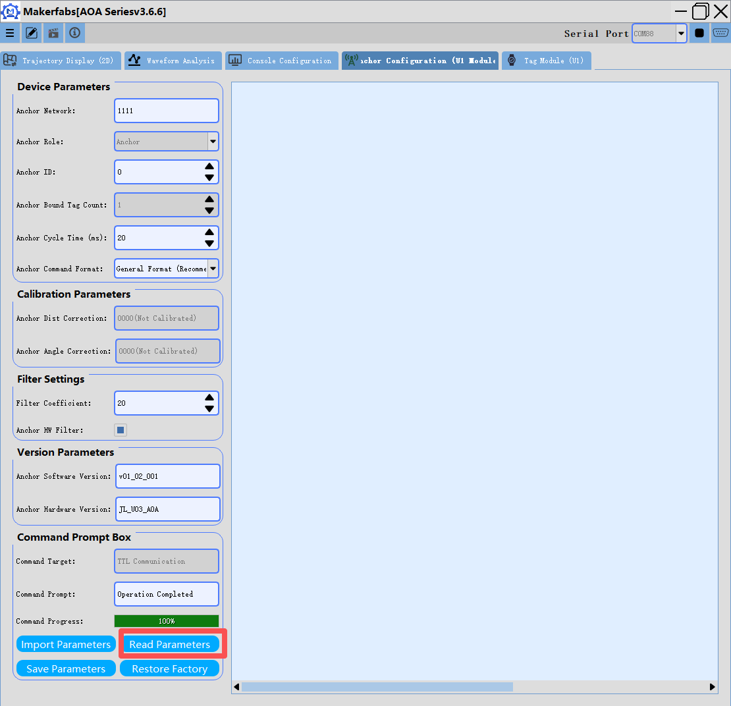

Write down the parameter instructions:
Step 1: Click on "Read All Parameters"
Step 2: Modify the parameters
Step 3: Click on "Import All Parameters"
Step 4: Click on "Save All Parameters"
